**bootcamp Database**

*Denise will create statements to create database and tables*

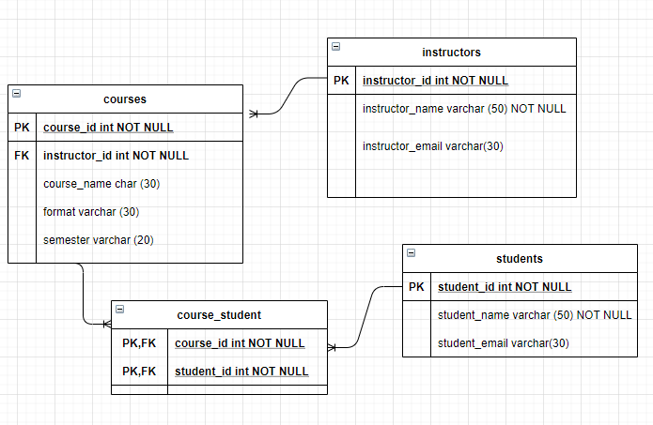

**Java Classes:**

**application Package:**

* Application
* Menu - *Zak will start outlining methods for menu*

**entities Package:**

*Anissa will start creating entity classes in Java*

* Student entity
* Course entity
* Instructor entity

**dao Package:**

* Student Dao
* Course Dao
* Instructor Dao
* DBConnection

Menu:

*Denise will write queries*

1. View all courses
2. View students in a course
   1. Enter course id
3. View a student and courses enrolled in
   1. Enter student id
4. View courses an instructor teaches
   1. Enter instructor id
5. Add a course

Enter Course ID

1. Enter Instructor ID
2. Enter Course Name
3. Enter Course Format
4. Enter Semester
5. Add an instructor
   1. Enter Instructor ID
   2. Enter Instructor Name
   3. Enter Instructor Email
6. Add a student
   1. Enter Student ID
   2. Enter Student Name
   3. Enter Student Email
7. Delete a course
   1. Enter course ID to be deleted
   2. Are you sure?
8. Delete an instructor
   1. Enter instructor ID to be deleted
   2. Are you sure?
9. Delete a student
   1. Enter student ID to be deleted
   2. Are you sure?
10. Update course
    1. Enter Course ID
    2. Enter Instructor ID
    3. Enter Course Name
    4. Enter Course Format
    5. Enter Semester
11. Update student
    1. Enter Student ID
    2. Enter Student Name
    3. Enter Student Email
12. Update instructor
    1. Enter Instructor ID
    2. Enter Instructor Name
    3. Enter Instructor Email
13. Exit